**Cyber Security**



**Assignment 02**

**Scanning**

Mir Hussain

023-19-0106

Submitted to Sir. Zakaria

**Nmap:**

**nmap -sT -p 445 192.168.1.102**

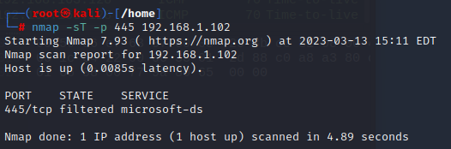

**Nmap with Wire**

**nmap -sT -p 3389 192.168.42.251**

**Wireshark**

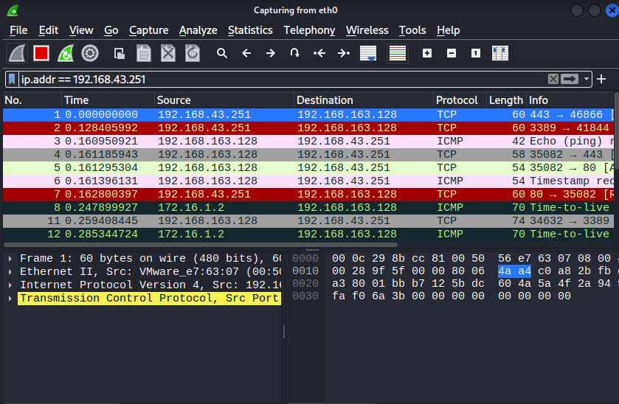

**Hping3**

**Nessus**

**Website:** [**www.iba-suk.edu.pk**](http://www.iba-suk.edu.pk)

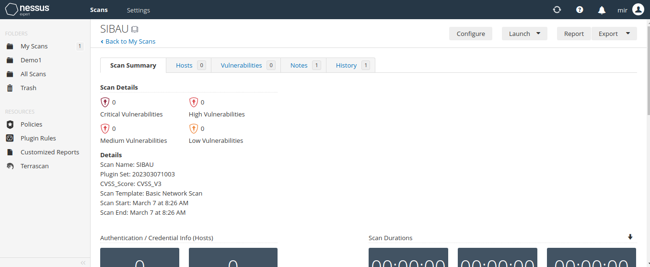

**Sindhhighcourt.gov.pk**



